**Galaxy Buds**

SM-R170NZKAPAK

[**Product Ratings :5.0(Number of Ratings :1)**](javascript:void(0))

* The next generation Galaxy Buds
* Quick pairing out of the box
* Fuller sound to get you really moving

**Looking for alternatives?**

This product is no longer available. Please choose another from the range.

[**Choose now**](https://www.samsung.com/pk/audio-sound/galaxy-buds/)

**Choose your color**

**Color :**black

* 
* 

**Galaxy Buds**

black

[**Where to buy**](javascript:;)

**The next generation Galaxy Buds**

They’re not just great for listening, they’re amazing for being heard too.

The next generation Galaxy Buds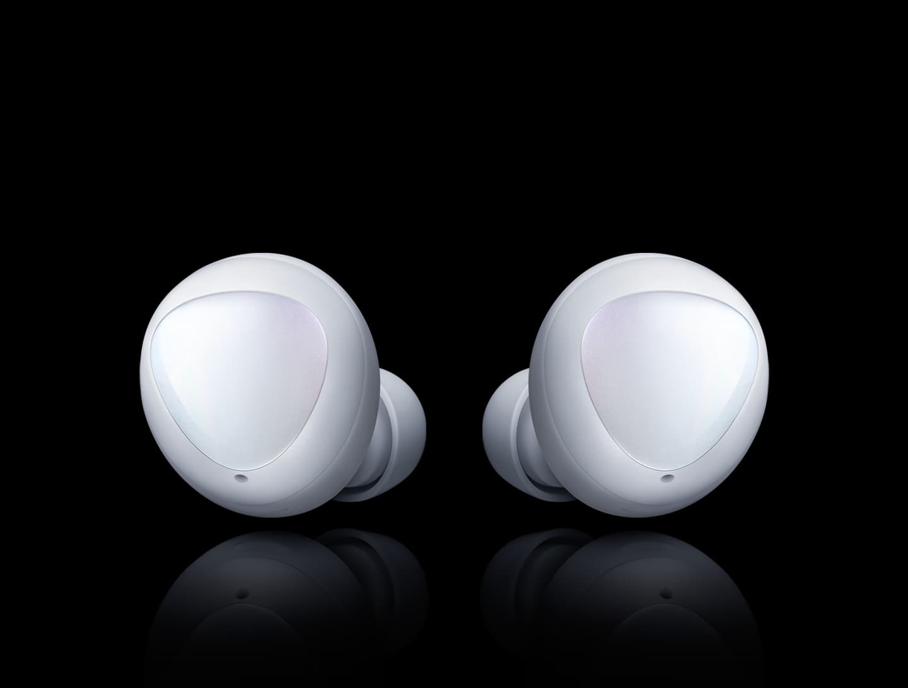

**Quick pairing out of the box**

Just pop open and pair. Galaxy Buds work right out of the box, connecting with your Galaxy devices in an instant via Bluetooth to get you up to the beat and well on your way.

* The connection pop-up window will appear only on Samsung mobile devices running Android 7.1.1 or lager that the SmartThings app installed. If the pop-up window does not appear, update the SmartThings app to the latest version.  
* This feature may vary by device, OS and depend on usageenvironment (Condition).  
* GUI of this feature is subject to change without prior notice.* Images and UX simulated.

Quick pairing out of the box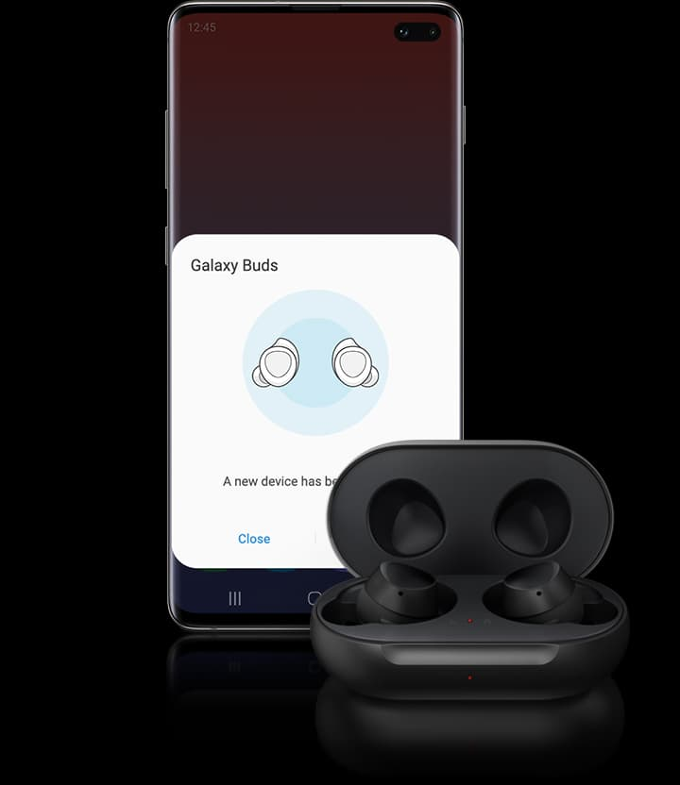

**Fuller sound to get you really moving**

Acoustic specialists sound by AKG have tuned Galaxy Buds to deliver incredibly rich,High Resolution live sound – dropping you front row at the gig, even when you’re not there.

* Galaxy Buds come fitted with medium size ear tips and wing tips, with small and large size ear and wing tips packaged in the same box. Choose the ear and wing tips that best fit your ear size for an optimum audio quality experience when listening to music and making calls.

Fuller sound to get you really moving

**Pocketable slim design on the go**

Slip them in your pocket and go. Galaxy Buds feature a newly refined design that makes them so compact they fit in comfortably with the rest of your belongings. They also come in standard color options that blend right in to your daily routine.

Pocketable slim design on the go

* Color options may vary by country

**Get your voice across clearly**

Our next-generation adaptive dual microphone technology makes background noise a thing of the past. Galaxy Buds recognize your surroundings, switching between inner and outer mics to keep unnecessary noise out of your conversation.

Get your voice across clearly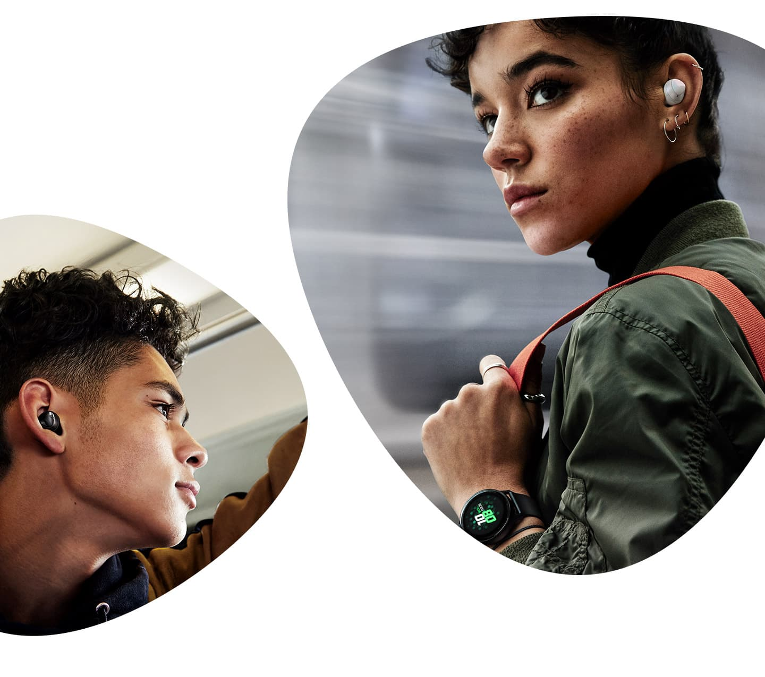

*Galaxy Watch Active sold separately.  
*Galaxy Buds come fitted with medium size ear tips and wing tips, with small and large size ear and wing tips packaged in the same box. Choose the ear and wing tips that best fit your ear size for an optimum audio quality experience when listening to music and making calls.

**Tuned into what surrounds you**

Stay in tune with the world around you. Galaxy Buds let you quickly shift your focus to your surroundings without taking them off, so you’ll never miss what’s coming and going.